Azure Event Grid is an eventing service for the cloud. In this article, you use the Azure CLI to create a custom topic, subscribe to the topic, and trigger the event to view the result. Typically, you send events to an endpoint that processes the event data and takes actions. However, to simplify this article, you send the events to a web app that collects and displays the messages.

When you're finished, you see that the event data has been sent to the web app.

If you don't have an Azure subscription, create a [free account](https://azure.microsoft.com/free/?ref=microsoft.com&utm_source=microsoft.com&utm_medium=docs&utm_campaign=visualstudio) before you begin.

Open Azure Cloud Shell

Azure Cloud Shell is a free, interactive shell that you can use to run the steps in this article. Common Azure tools are preinstalled and configured in Cloud Shell for you to use with your account. Just select the **Copy** button to copy the code, paste it in Cloud Shell, and then press Enter to run it. There are a few ways to open Cloud Shell:

|  |  |
| --- | --- |
| Select **Try It** in the upper-right corner of a code block. | Cloud Shell in this article |
| Open Cloud Shell in your browser. | <https://shell.azure.com/bash> |
| Select the **Cloud Shell** button on the menu in the upper-right corner of the [Azure portal](https://portal.azure.com). | Cloud Shell in the portal |
|  |  |

If you choose to install and use the CLI locally, this article requires that you are running the latest version of Azure CLI (2.0.24 or later). To find the version, run az --version. If you need to install or upgrade, see [Install Azure CLI 2.0](https://docs.microsoft.com/en-us/cli/azure/install-azure-cli).

If you aren't using Cloud Shell, you must first sign in using az login.

Create a resource group

Event Grid topics are Azure resources, and must be placed in an Azure resource group. The resource group is a logical collection into which Azure resources are deployed and managed.

Create a resource group with the [az group create](https://docs.microsoft.com/en-us/cli/azure/group#az_group_create) command.

The following example creates a resource group named *gridResourceGroup* in the *westus2* location.

Azure CLI Copy Try It

az group create --name gridResourceGroup --location westus2

baejang_t@Azure:~$ az group create --name gridResourceGroup --location westus2

{

"id": "/subscriptions/1c612728-8a3f-40cf-a96a-ea3d3c3b8fdf/resourceGroups/gridResourceGroup",

"location": "westus2",

"managedBy": null,

"name": "gridResourceGroup",

"properties": {

"provisioningState": "Succeeded"

},

"tags": null

Create a custom topic

An event grid topic provides a user-defined endpoint that you post your events to. The following example creates the custom topic in your resource group. Replace <your-topic-name> with a unique name for your topic. The topic name must be unique because it's part of the DNS entry.

Azure CLI Copy Try It

topicname=joycetopic

az eventgrid topic create --name $topicname -l westus2 -g gridResourceGroup

"endpoint": "https://joycetopic.westus2-1.eventgrid.azure.net/api/events",

"id": "/subscriptions/1c612728-8a3f-40cf-a96a-ea3d3c3b8fdf/resourceGroups/gridResourceGroup/providers/Microsoft.EventGrid/topics/joycetopic",

"location": "westus2",

"name": "joycetopic",

"provisioningState": "Succeeded",

"resourceGroup": "gridResourceGroup",

"tags": null,

"type": "Microsoft.EventGrid/topics"

}

Create a message endpoint

Before subscribing to the topic, let's create the endpoint for the event message. Typically, the endpoint takes actions based on the event data. To simplify this quickstart, you deploy a [pre-built web app](https://github.com/dbarkol/azure-event-grid-viewer) that displays the event messages. The deployed solution includes an App Service plan, an App Service web app, and source code from GitHub.

Replace <your-site-name> with a unique name for your web app. The web app name must be unique because it's part of the DNS entry.

Azure CLI Copy Try It

sitename= joycebzhangweb

az group deployment create \

--resource-group gridResourceGroup \

--template-uri "https://raw.githubusercontent.com/dbarkol/azure-event-grid-viewer/master/azuredeploy.json" \

--parameters siteName=$sitename hostingPlanName=viewerhost

The deployment may take a few minutes to complete. After the deployment has succeeded, view your web app to make sure it's running. In a web browser, navigate to: https://<your-site-name>.azurewebsites.net

You should see the site with no messages currently displayed.

Subscribe to a topic

You subscribe to a topic to tell Event Grid which events you want to track and where to send those events. The following example subscribes to the topic you created, and passes the URL from your web app as the endpoint for event notification.

The endpoint for your web app must include the suffix /api/updates/.

Azure CLI Copy Try It

endpoint=https://$sitename.azurewebsites.net/api/updates

az eventgrid event-subscription create \

-g gridResourceGroup \

--topic-name $topicname \

--name demoViewerSub \

--endpoint $endpoint

View your web app again, and notice that a subscription validation event has been sent to it. Select the eye icon to expand the event data. Event Grid sends the validation event so the endpoint can verify that it wants to receive event data. The web app includes code to validate the subscription.

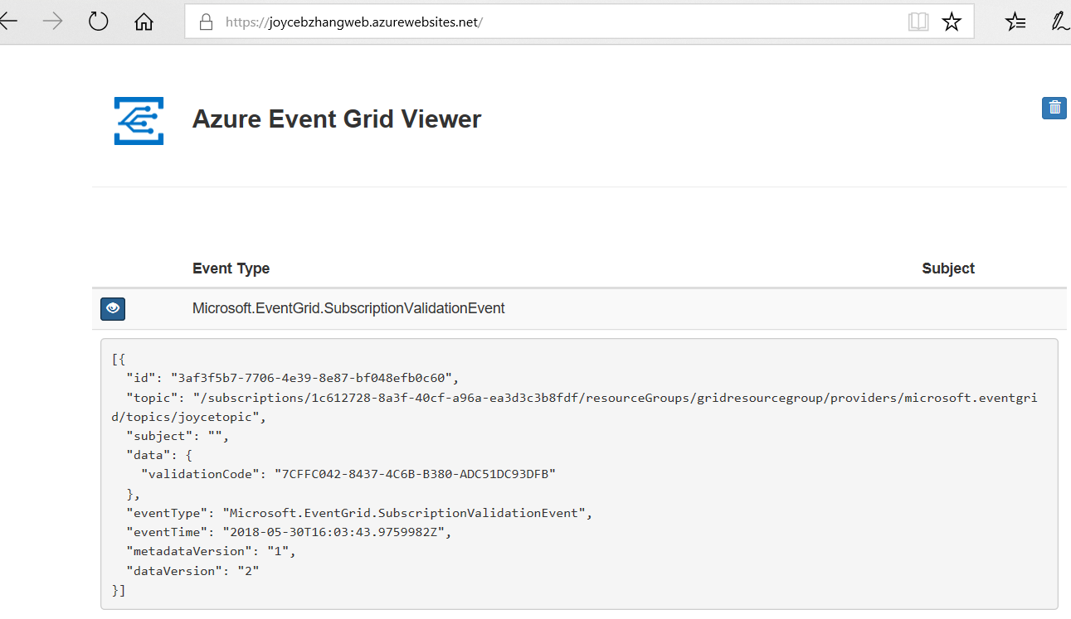

Send an event to your topic

Let's trigger an event to see how Event Grid distributes the message to your endpoint. First, let's get the URL and key for the custom topic.

Azure CLI Copy Try It

endpoint=$(az eventgrid topic show --name $topicname -g gridResourceGroup --query "endpoint" --output tsv)

key=$(az eventgrid topic key list --name $topicname -g gridResourceGroup --query "key1" --output tsv)

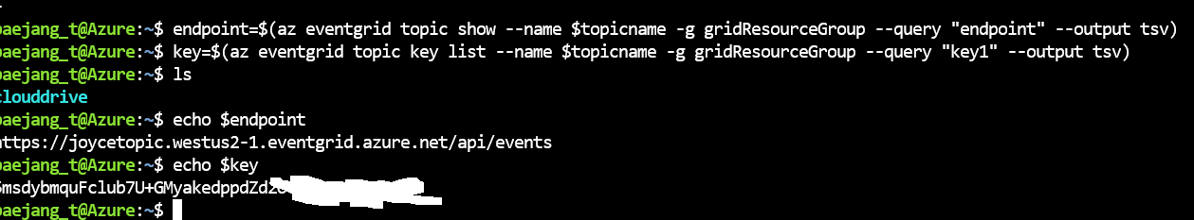

To simplify this article, you use sample event data to send to the topic. Typically, an application or Azure service would send the event data. The following example gets the event data:

Azure CLI Copy Try It

body=$(eval echo "'$(curl <https://raw.githubusercontent.com/Azure/azure-docs-json-samples/master/event-grid/customevent.json)>'")

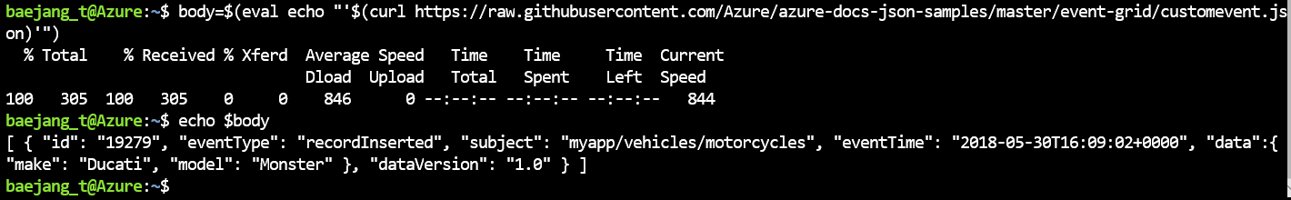

To see the full event, use echo "$body". The data element of the JSON is the payload of your event. Any well-formed JSON can go in this field. You can also use the subject field for advanced routing and filtering.

CURL is a utility that sends HTTP requests. In this article, use CURL to send the event to the topic.

Azure CLI Copy Try It

curl -X POST -H "aeg-sas-key: $key" -d "$body" $endpoint

You've triggered the event, and Event Grid sent the message to the endpoint you configured when subscribing. View your web app to see the event you just sent.

JSON Copy

[{

"id": "1807",

"eventType": "recordInserted",

"subject": "myapp/vehicles/motorcycles",

"eventTime": "2017-08-10T21:03:07+00:00",

"data": {

"make": "Ducati",

"model": "Monster"

},

"dataVersion": "1.0",

"metadataVersion": "1",

"topic": "/subscriptions/{subscription-id}/resourceGroups/{resource-group}/providers/Microsoft.EventGrid/topics/{topic}"

}]

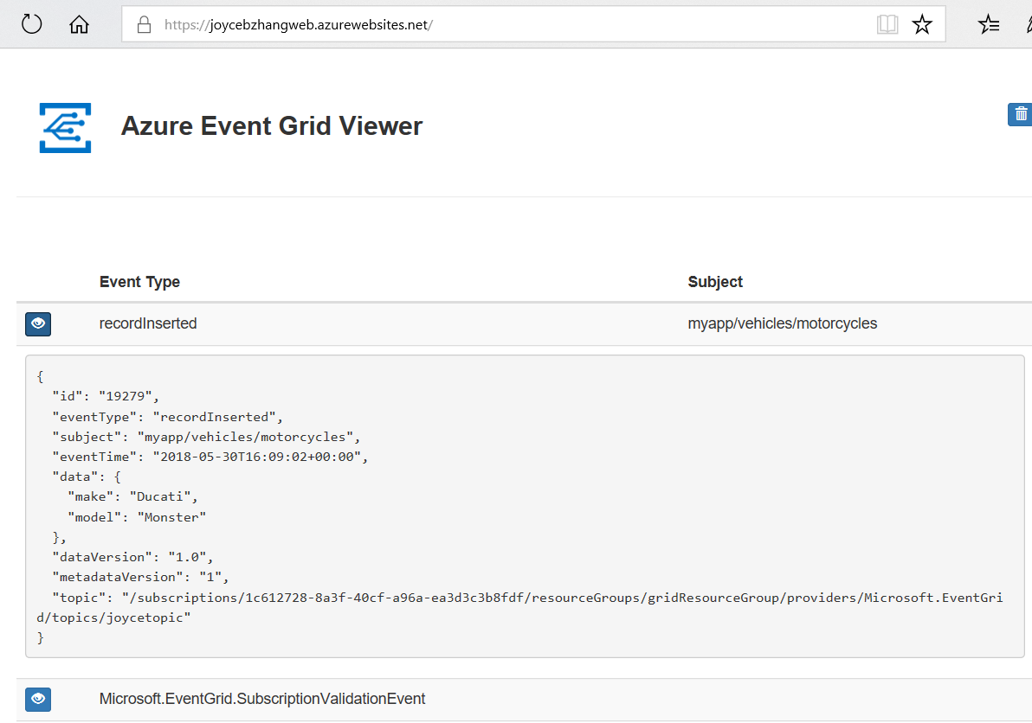

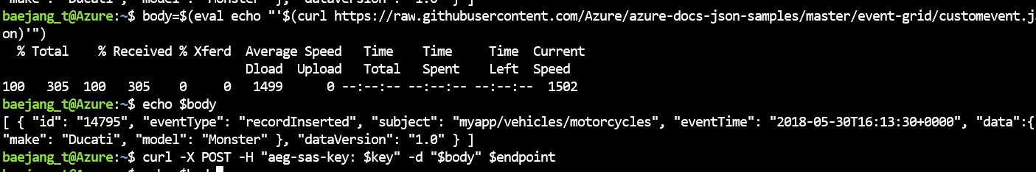

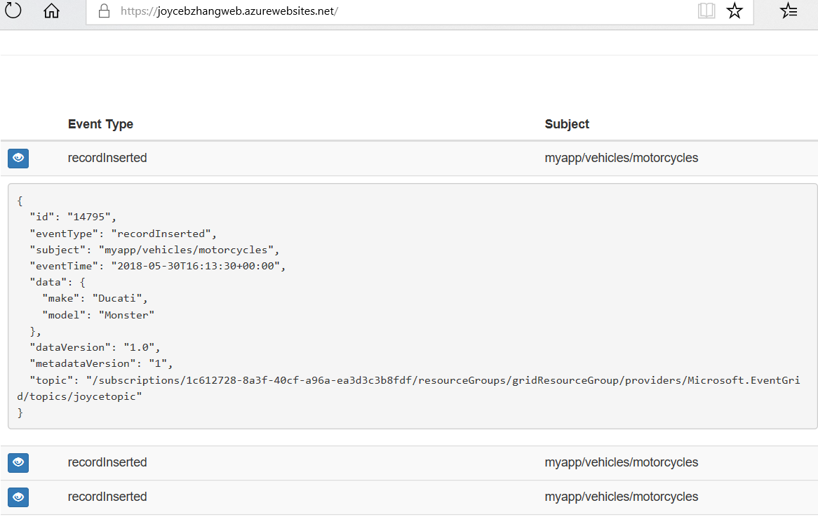

Clean up resources

If you plan to continue working with this event or the event viewer app, don't clean up the resources created in this article. Otherwise, use the following command to delete the resources you created in this article.

Azure CLI Copy Try It

az group delete --name gridResourceGroup